

**UNIVERSITY OF PETROLEUM AND ENERGY STUDIES**

**School of Computer** **Science**

**2020-21**

**GRAPHICS AND ANIMATION TOOLS LAB**

**Faculty: Dr. DURGANSH SHARMA**

**Assistant Professor**

**Department of Cybernetics.**

**School of Computer Science, UPES**

**Submitted By:**

**Name- Garima Dhall**

**Roll no-R100217025**

**Batch-B1**

**Semester- 7**

**Course-B.tech. CSE-OSOS**

**Sap Id- 500062498**

**EXPERIMENT NO 8**

**Aim** :- Design of 3D Car using Blender.

**Objective** :- To Design a 3D Car using features of Blender 2.8.

**STEPS TO MAKE DESIGN A 3D CAR:-**

1. Open Blender workspace and add the cube and adjust its length and breadth according to the shape of the low poly car

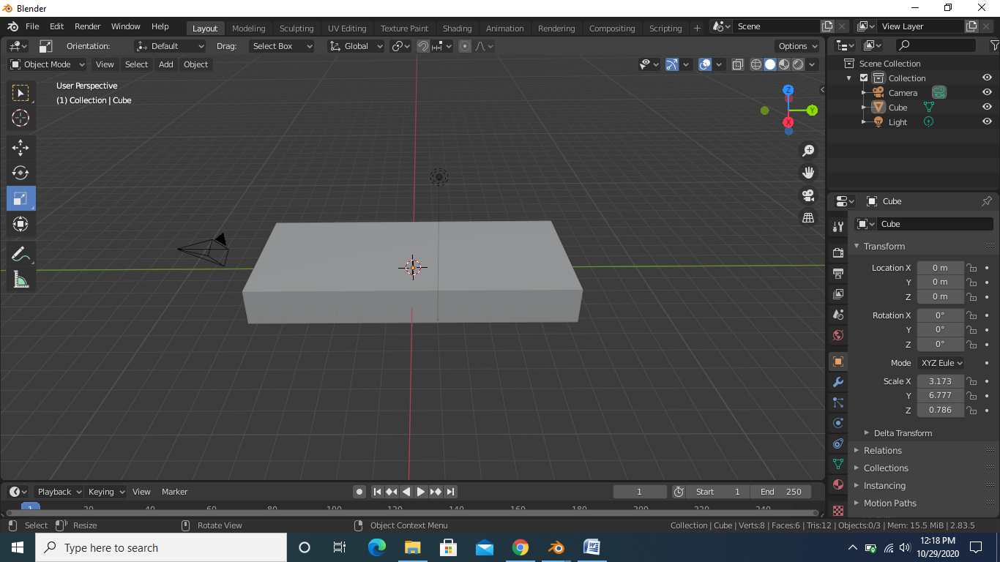

1. Then we will move in edit mode and make loop cut in center of the cube and after that we will extrude the loop cut area and then bevel the loop cut and then scale it to form the top surface of the car

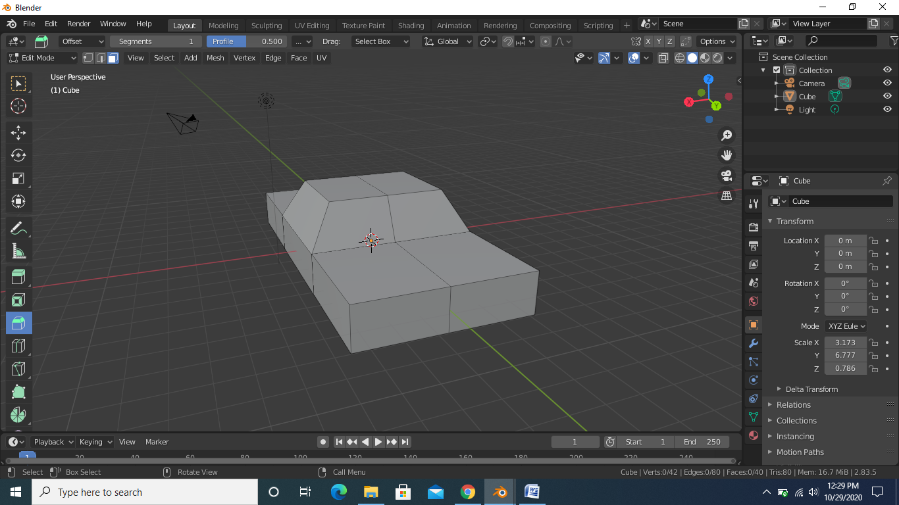

1. After doing the above step we will cut the other half of the car and then add mirror modifier make sure to select clipping option in mirror modifier

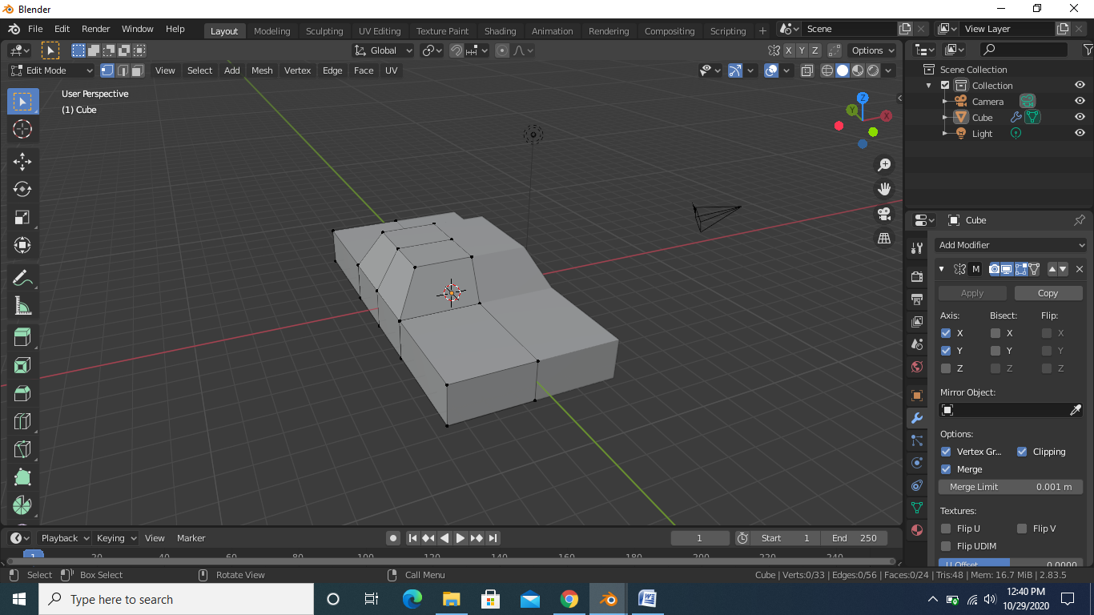

1. After the above step we will insert the faces and make the shape of the windows

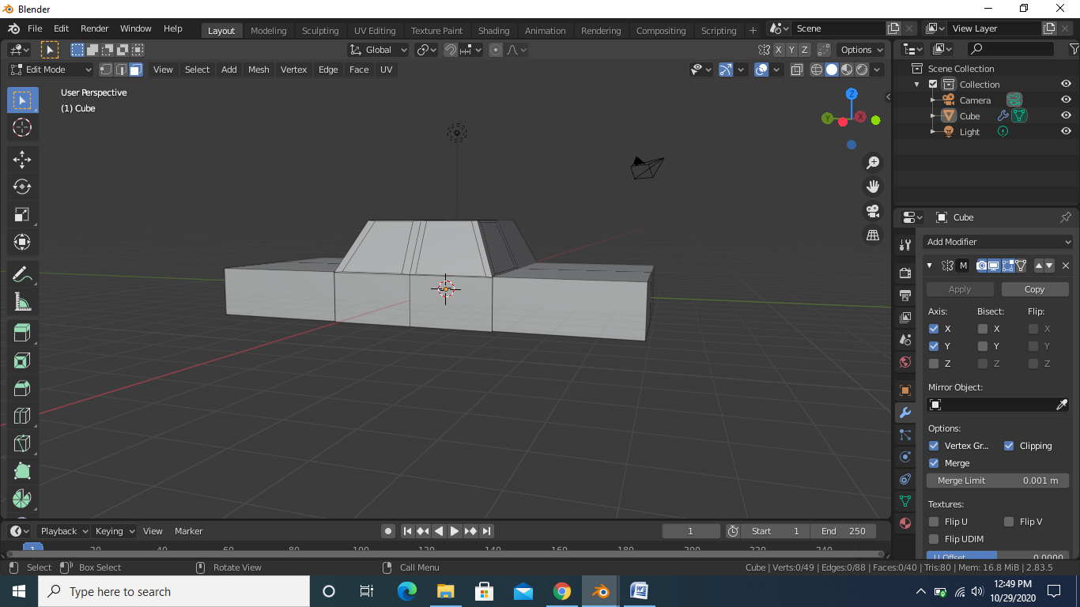

1. After the above step now we will add the cylinder to make the wheels of the car and we will make the headlights of the car by adding another cylinder

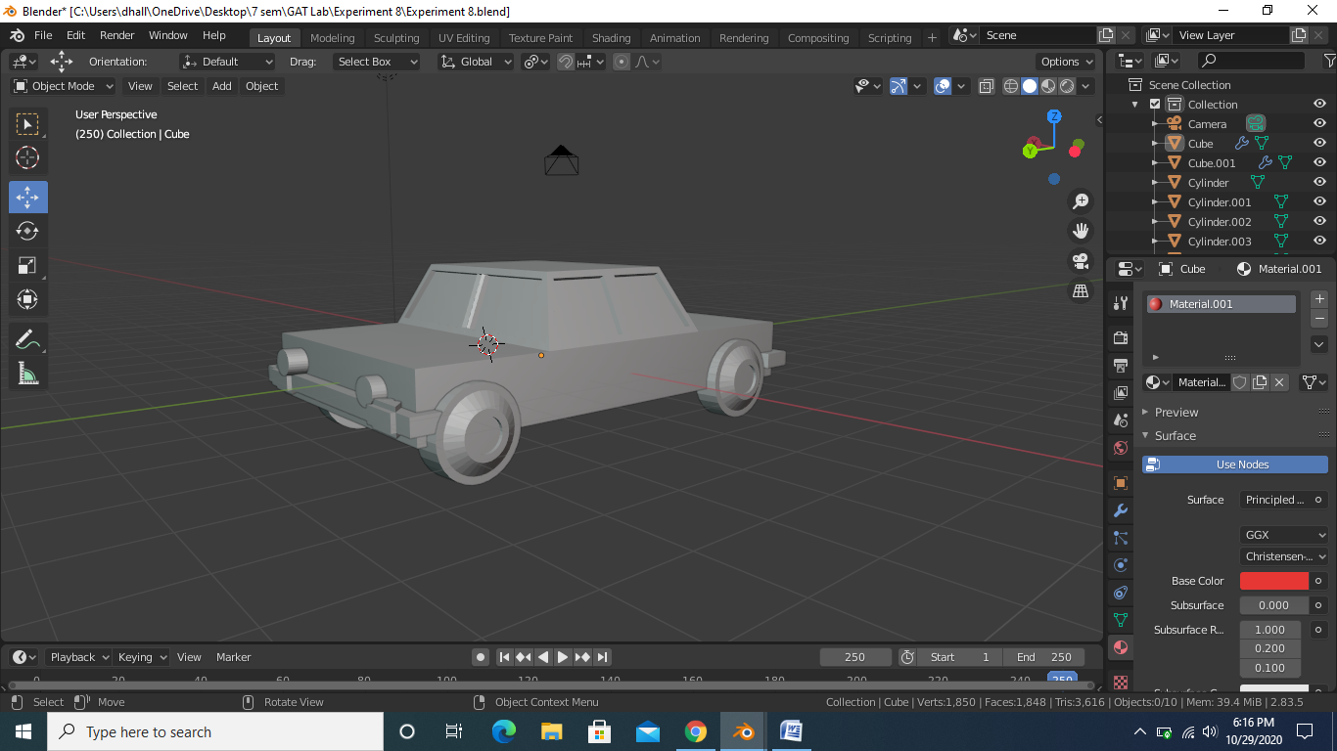

1. After the above step we will assign the color to the car

